**Smart button in type [object]**

**Step 1: Create a model**

* Add a count field and its method
* Add button type object method

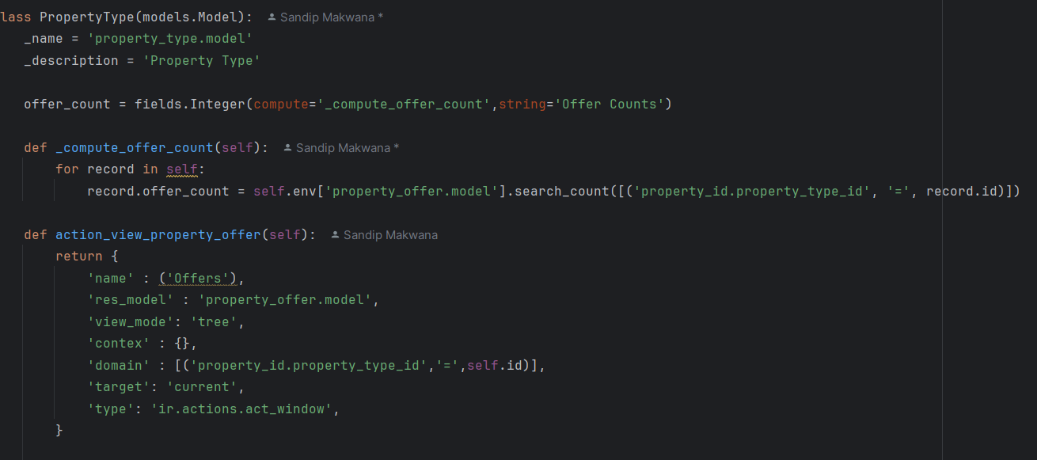

**Step 2: Create a button**

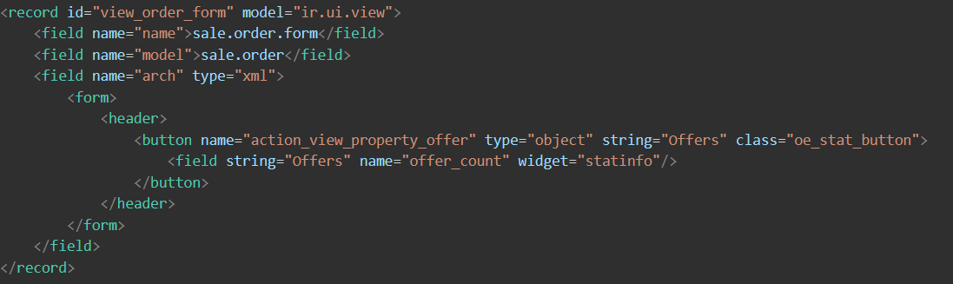

**Smart button in type [action]**

**Step 1: Create a model**

* Add a count field and its method

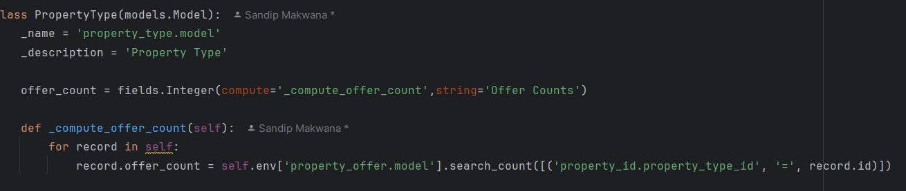

**Step 2: Create a button and action**

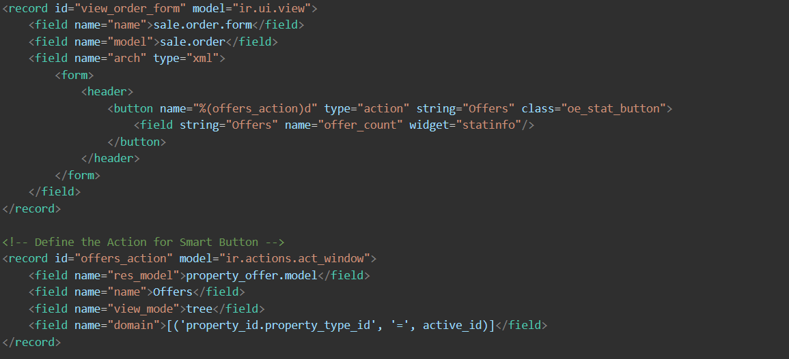

**Or use button like this**

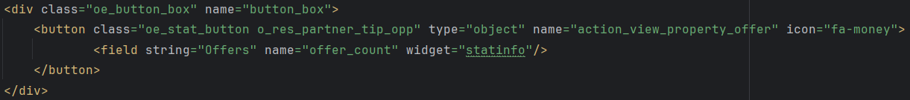

**Smart button img**

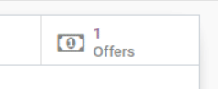



In Odoo, **Smart Buttons** and **Stat Buttons** are similar in functionality but serve slightly different purposes. Here's the distinction:

**1. Smart Buttons**

* Found in the **form view** of a record.
* Displayed as clickable buttons above the form header.
* Used to provide a shortcut to related records (e.g., a button to see all invoices linked to a customer).
* Usually defined in Python using the @api.depends decorator or in XML using <button> with type="action".

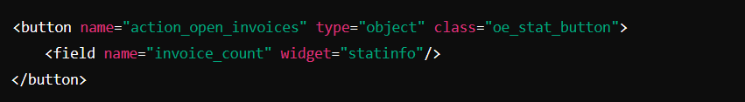

**2. Stat Buttons**

* A special type of button used **inside the kanban view or dashboard**.
* Typically used to display statistics, such as counts of related records.
* Usually implemented in XML using <div class="o_stat_info">.
* Example in Kanban View:

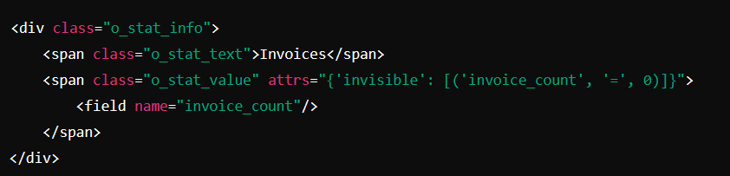

**Key Differences**

| **Feature** | **Smart Button** | **Stat Button** |
| --- | --- | --- |
| Location | Form view | Kanban/dashboard view |
| Purpose | Shortcut to related records | Display statistics |
| Clickable | Yes | No (mostly for display) |
| Implementation | <button> in form view | <div class="o_stat_info"> in kanban |

**Conclusion**

Both are used to **display information and provide navigation**, but **smart buttons** are more interactive, while **stat buttons** are mainly for displaying statistics.